
TEL 1-866-XANATOS

INSTALLATION INSTRUCTIONS
OEM REPLICA RUNNING BOARD
FORD RANGER #RFORA19

FORD RANGER OEM RUNNING BOARD INSTRUCTION
Item number：RFORA19
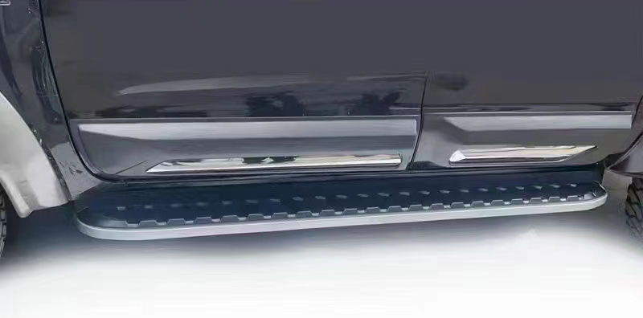
PARTS LIST

NO | NAME | QTY | SPECIFICATION
1 | RUNNING BOARD | 2
2 | BRACKET | 6
3 | Hex bolt | 12 | M8*25
4 | WASHER | 12 | M20*10*1.2
5 | T bolt | 12 | M8*20
6 | WASHER | 12 | M20*8*1.2
7 | NUT | 12 | 8MM
PROCEDURE

1 Remove contents from box , verify all parts are presents , read instructions carefully before starting installation .
- Down of the cars, you will see there are some predrilled holes in side of the car. The holes are threaded for the factory steps. So we just removed the plastic caps , line up the bracket. Use the hex bolt (M8*25) to threading them by hand ,and then use the grab our ratchet to tight the bracket. You can referent below image:
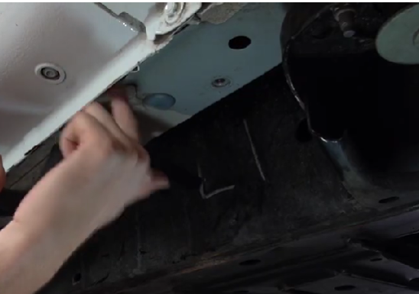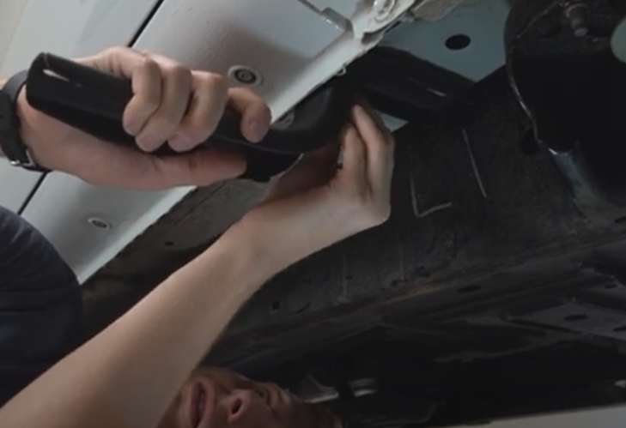
Pre-drilled holes on the bottom of the cars take of the plastic cab and line up bracket
- Repeat the same step to install the middle and rear brackets
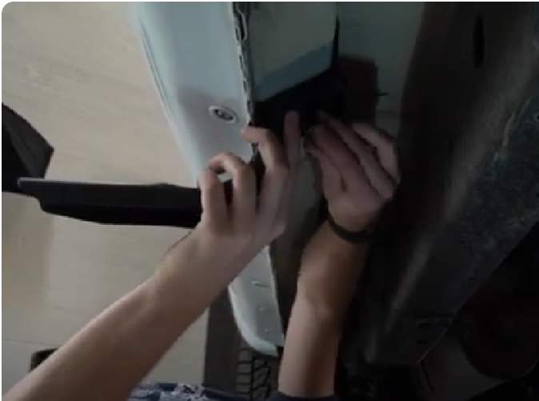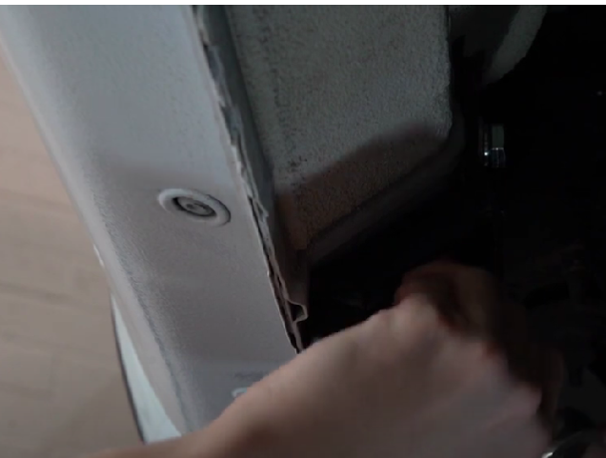
Middle bracket installation Rear bracket installation
- After three brackets are tighten , put the running broad on the brackets on use the hex bolt nuts fix on the back of the running board. Tighten the nuts.(the step as image).
- The running board back side installation:
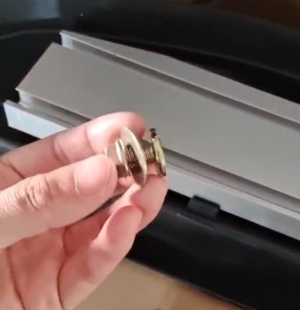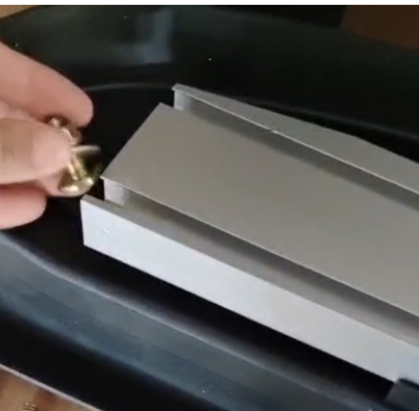
A.Put M8 nut, washer and M8*20 T bolt together B. slide them in the groove on the back side
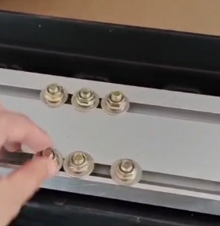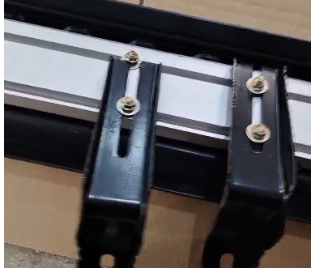
C.One side item need 3sets hardware kit D. Inset the bracket and adjust to the right position
- Move the brackets to the right position and tighten the screws. The running board will be finish installation.
- Repeat the same steps on the other side.
- Double check , make sure all bolt and fasteners placed properly . Done

